PERSONA: Energetic Millennial Kara

TOPIC: Mobility

**EMPATHISE AND DEFINE:**

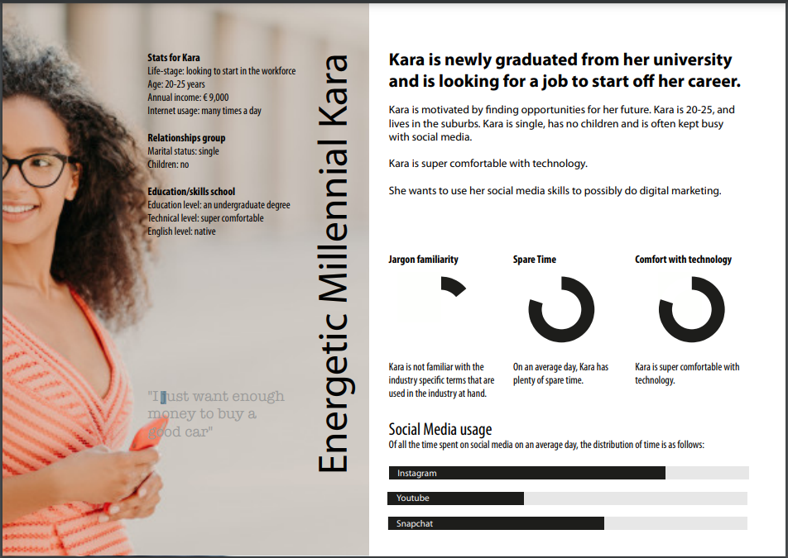

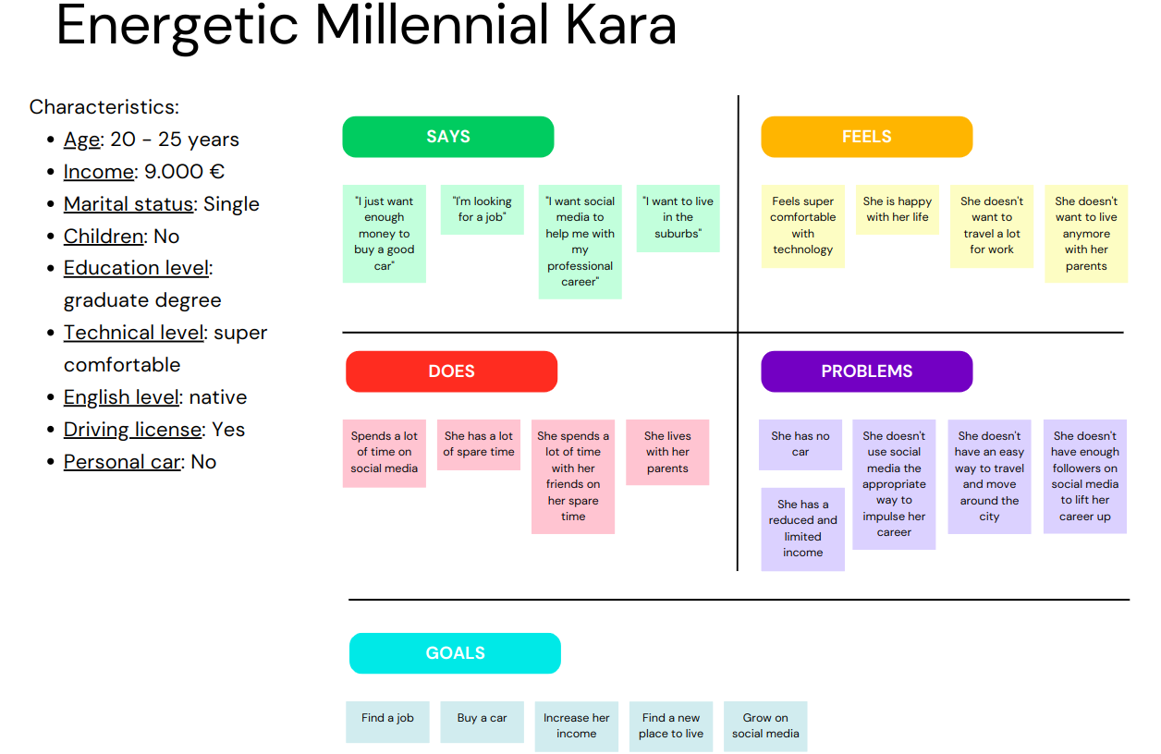

**Needs:**

* She needs a job
* She needs a car
* She needs a way to move around
* She needs more money
* She needs more followers on social media

**Problems to solve:**

* Finding an easy and cheap way to move around the city and to the center specially
* Find a way to earn more money
* Find a way to make more followers on her social media
* Find a job to increase her income

**How might we questions:**

* How might we get more followers for our targer audience?
* How might we get a cheap way to travel around?
* How might we help our targer audience earn more money?
* How might we help our target audience find a job?

**Problem statements:**

[**User** . . . (descriptive)] needs [**need** . . . (verb)] because [**insight.** . . (compelling)]

* Our persona needs an easy and cheap way to travel because she lives in the suburbs and she doesn't have a car, so she needs transport to go to places. It has to be cheap because she has a reduced income.
* Our persona needs more followers on her social media, because she wants to make a living from her social media with her digital marketing.
* Our persona needs a job, because she wants to buy a car and she wants to go living on her own.
* Our persona needs a way to make more money (like investements) because she wants to buy a car and she wants to go living on her own.

**We will focus mainly in the first problem because is the one that is more related to out topic: mobility, trying to also satisfy as much as possible the other ones.**

**IDEATION:**

Solutions have to be cheap because she doesn’t have a lot of money and has to save up for a car.

**IDEAS**:

* App to find people that go by car to the same place as you and share the costs (Carpool)
* Find all the public transport options to go somewhere
* An app to find second hand or cheap cars
* An app to see all rental bikes in the neigbourhood
* A taxi booking app
* Share a taxi app; share a taxi with someone to lower the costs
* Community app for people who want to go in the same direction and time
* Public transportation app

**Similar apps:**

* Bla Bla Car: It’s an app to find people that goes to the same place as you and join one of that people’s car to share the costs of the travel.
* Google Maps, NS, 9292, Omio: Public transportation app to find the best route for your travelling.
* Bolt: It's an app were you can order a taxi (local people), but you can also rent steps and scooter. You can pay in the app and you can leave reviews in there.
* Uber: Is also an app were you can order a taxi. Also you can pay in the app and leave reviews.
* Taxi.eu: Is an app were you can order a taxi and pay it. You can leave a review there if you want.
* Wallapop, Markplaats: Apps for buying and selling second hand things: clothes, cars, bikes, …

Main Idea:

An app to find people that does the same travel as you at a similar time, then you will be able to make groups with that people and share a car if someone has or order a taxi.

**PROTOTYPING:**

**Requirements:**

* Location description
* Accounts
* Options to choose who you want to travel with
* Maximum seats in car or taxi
* I have a car, I don’t have a car system
* “A map were you can order a taxi nearby”
* Review system
* Paying system
* Calculate the costs of travel
* Chat for people to meet up
* Meeting point and time
* Privacy and safety
* User friendly

In the home screen of the app you will be able to choose where you are, where you want to go and at what time, then you will see al the people with the same input (time&where) and you will be able to choose with who you want to travel with. People that have a car can introduce it with the amount of free seats it has, otherwise the groups will be at most of 4, to fit in a taxi. The groups in which one person has a car will meet at the time and place the drives says, and the other groups will have the option to call a taxi.

Check out the prototype in here: <https://xd.adobe.com/view/e6dc87c3-99ef-47b1-875d-7d7104e9f765-b38f/>

**TESTING:**